Four Weeks Industrial Training Project Report
On
“HER-ALERT
A Smart Women Safety Website Build Using Frontend Technologies”

Submitted in the partial fulfilment of the requirements for the award of degree of
Bachelor of technology
in
Computer Science and Engineering
Batch
(2023-2027)

Submitted to: Submitted by:
Ms. Ridhi Kapoor Kamna Manhas
Assistant Professor(CSE) 12300439

DAV UNIVERSITY
JALANDHAR -PATHANKOT NATIONAL HIGHWAY, NH 44, 144102

ABSTRACT

Her Safety is a web-based women’s safety platform designed to provide quick access to emergency services, real-time location sharing, and safety awareness tools. The objective of this project is to help women respond faster in threatening or unsafe situations by offering essential features in one simple interface.
The system includes instant call buttons, such as Police (100), Women Helpline (1091), and Domestic Violence Helpline (181), allowing users to seek help with a single tap. The SOS feature captures the user’s live location and displays it on an interactive map using GPS and Leaflet.js, helping the user share their coordinates during emergencies. The project also provides a siren alarm, trusted contact call option, and Google Maps search for nearby police stations, ensuring quick assistance in urgent situations.
Additionally, the platform includes a reporting system where users can submit incident details securely, along with safety tips to increase awareness and preparedness. A simple safety quiz is also added to enhance learning. A dark mode toggle improves accessibility and user comfort.
Developed using HTML, CSS, and JavaScript, Her Safety focuses on practicality, responsiveness, and ease of use. This project demonstrates how modern web technologies can contribute to women’s safety by offering fast assistance, awareness, and confidence during emergencies.

ACKNOWLEDGEMENT

I express my gratitude to all those who helped us in various stages of the development of this
project. First, I would like to express my sincere gratitude indebtedness
to Ms. Ridhi Kapoor, for allowing me to undergo the summer training of 45 days at Future Finder Company. I am also thankful to all faculty members of Department of Computer Science and Engineering, for their true help, inspiration and for helping me for the preparation of the final report and presentation.
Last but not least, I pay my sincere thanks and gratitude to all the Staff Members
of Future Finder for their support and for making our training valuable
and fruitful.

TRAINING CERTIFICATE



DECLARATION

I, Kamna Manhas, hereby declare that the work which is being presented in this
project titled “HER-ALERT: A Smart Women Safety Website Build Using
Frontend Technologies” by me, in partial fulfilment of the requirements for the
award of Bachelor of Technology (B. Tech) Degree in “Computer Science and
Engineering” is an authentic record of my own work carried out under the guidance
of Mr. Gautam. To the best of my knowledge, the matter embodied in this report has not been submitted to any other University/ Institute for the award of any degree or diploma.

Student Name and Signature
Kamna Manhas

Roll No. - 12300439

TABLE OF CONTENT

SR. NO. | CONTENT TITLE | PAGE NO.
1 | INTRODUCTION | 7-9
2 | OBJECTIVES | 10-11
3 | STEPS TO ACHIEVE  OBJECTIVES | 12-13
4 | COMPOMNENTS USED IN THIS PROJECT | 14-15
5 | PROBLEM STATEMENT | 16-17
6 | TECHNOLOGIES IN USE | 18-19
7 | CODING AND  IMPLEMENTATION | 20-31
8 | FUTURE SCOPE | 32
9 | CONCLUSION | 33
10 | REFERENCES | 34

- INTRODUCTION

Women’s safety has emerged as one of the most critical social, technological, and humanitarian concerns in modern society. With the rapid rise of urbanization, increased mobility, and changing lifestyles, women frequently encounter environments where safety cannot always be assured. Instances such as harassment, stalking, domestic violence, abduction, and other forms of crime have reinforced the need for reliable protective measures accessible at all times. While law enforcement agencies and government bodies have implemented several initiatives, the need for technology-driven solutions that offer real-time support, instant communication, and immediate emergency response continues to grow.
In this context, the integration of proactive digital tools can play a vital role in preventing and responding to unsafe situations. As a result, the development of a Women Safety Helpline System becomes an essential technological intervention aimed at empowering women and enhancing their personal security through effective digital mechanisms.

This project, titled "Crime Analysis & Women Safety Helpline System", is a practical implementation of how web technologies can be utilized to build a real-time safety support system. The system leverages the capabilities of JavaScript, HTML, CSS, and mapping libraries such as Leaflet.js to offer location detection, emergency service accessibility, SOS signaling, and awareness features — all packed within a single, user-friendly interface. By combining location-based services, alert systems, and interactive learning tools, the project aims to create a multifunctional platform that supports women during emergencies and promotes awareness on preventive safety measures.

The primary motivation behind designing this system is the growing need for easily accessible emergency tools available on everyday devices like smartphones and laptops. Traditional safety mechanisms such as calling helpline numbers, seeking help from nearby individuals, or using physical alarms may not always be practical during threatening situations. Therefore, the integration of digital emergency functionalities helps in overcoming limitations like delayed communication, unavailability of physical help, or inability to contact authorities manually. With one click, users can instantly ring an alarm, call

emergency numbers, send their location, and alert trusted contacts, thus reducing critical response time.

The Women Safety Helpline System consists of several essential modules, each designed to serve a unique purpose. The Quick Action Buttons provide immediate access to emergency services, including calling the police, contacting a trusted person, triggering a loud siren, or searching for nearby police stations. These buttons are developed using JavaScript functions that simulate phone ringing tones and alert sounds, making them intuitive and easy to use. The ringtone-based calling simulation not only gives a realistic calling effect but also ensures the user receives instant audio feedback during an emergency.

Another major component of the project is the SOS Feature, which uses the device’s GPS to fetch the user’s latitude and longitude. This information is displayed to the user and can be shared with authorities or trusted individuals for immediate assistance. The integration of Leaflet maps further enhances the system by visually representing the user’s location on both a primary map and a mini map. These maps assist in identifying surroundings, verifying current location, and navigating towards safer spaces or nearby police stations.

The platform also includes a Report Incident module, which allows users to document incidents directly through the website. This ensures that even after the emergency moment has passed, the user can formally report the incident for further investigation. The input fields allow for non-mandatory personal information, ensuring privacy and encouraging more individuals to report crimes without fear or hesitation. This feature supports long-term crime analysis by collecting structured data that can be used by authorities or researchers to identify patterns, unsafe zones, or recurring criminal behaviors.

To further strengthen awareness, the system features a dedicated Safety Tips section that educates users about preventive measures and safe practices. It includes tips for avoiding dangerous situations, staying prepared, and using technology effectively to enhance personal security. Additionally, an interactive Safety Quiz is implemented to test the user’s knowledge

and promote active learning. This ensures the project not only serves as an emergency infrastructure but also contributes to behavioral awareness and self-defense preparedness.

Another important feature is the incorporation of Dark Mode, allowing users to switch between light and dark themes. This enhances usability in low-light conditions and contributes to user comfort, especially during nighttime usage, when the likelihood of unsafe situations increases. The project’s responsive design ensures that all features work efficiently across different devices, making it a flexible solution for a broad range of users.

The overall aim of this project is to demonstrate how modern web technologies can be creatively employed to build solutions that address real-world problems. Crime against women remains a persistent societal issue, and while no single tool can entirely eliminate risks, digital interventions like this system can substantially reduce vulnerability by improving communication, enhancing awareness, and strengthening emergency response. This project aligns with the broader vision of using technology to promote social welfare, safety, and equality.

Through this project, the integration of crime analysis, location-based safety tools, and user education offers a comprehensive system that contributes to a safer environment for women. By bridging the gap between emergency services and individuals in distress, the Women Safety Helpline System stands as an example of how technology can empower society and support women in reclaiming their right to safety. The project further highlights the role of engineering students and future technologists in creating impact, meaningful solutions for the community.
2.OBJECTIVES

The main objectives of the Her Safety – Women Safety Web Application project are:
- To develop a user-friendly safety platform for women
The aim is to create an intuitive website that any user can easily access during emergencies without confusion or delay. Buttons, text, and features are kept clear and simple.
- To integrate real-time location tracking using Geolocation API
This helps users send their exact coordinates when they are in danger. It allows quick support by police, family, or emergency services.
- To provide essential emergency features on a single screen
Instant call buttons (Police 100, Women Helpline 1091, Domestic Violence 181), a siren alarm, and trusted contact calling ensure immediate help.
- To design a safe incident reporting system
Users can submit incident details securely, allowing authorities or administrators to document and respond effectively.
- To increase safety awareness through tips and quizzes
Safety tips help users act smartly in risky situations. The safety quiz improves knowledge and encourages careful behavior.
- To understand and apply frontend development skills
The project strengthens skills in HTML, CSS, and JavaScript and teaches integration of APIs and external libraries like Leaflet.js.
- To create a visually appealing and responsive interface
The website adapts to desktops, tablets, and mobile screens to ensure accessibility for all users.

a) Identify Training Area
The training area refers to the specific field or domain in which the student receives
exposure. In this context, the training area involved learning frontend development
technologies such as HTML, CSS, and JavaScript, as well as understanding how
these technologies are applied in real-world projects like women-safety platforms.
The goal as to gain technical experience, improve problem-solving ability, and
understand how web interfaces are created and made interactive.
(b) Training Program
The training program is the structured learning plan provided by the organization.
It generally includes learning sessions, guided tasks, practical assignments, and
evaluation.
The purpose of the program is to develop the trainee’s knowledge of web technologies,
understand design principles, learn coding practices, and gain confidence in building
functional webpages.
The program also introduces tools used in development such as code editors, version
control, debugging techniques, and UI planning.
(c) Tasks Assigned to You- During the training, various tasks were given to ensure
practical learning.
Typical tasks included:
  - Designing basic webpage layouts using HTML structure
  - Styling elements with CSS, focusing on responsiveness and clean interfaces.
  - Adding interactivity using JavaScript, such as button actions or animations.
  - Creating specific modules related to the project—for example, an SOS button,
  - alert messages, or forms.
Testing the functionality to ensure that features work properly across browsers.
These tasks helped in understanding how theory converts into real applications.

3. Steps to Achieve the Objectives

To successfully complete the objectives, a series of steps were followed. These steps
ensured systematic learning and proper completion of every assigned activity.

Step 1: Understanding the Training Requirements
The first step was to clearly understand what the training demanded—what skills were required, what tools would be used, what modules needed to be built, and how the final output should look.
This step helped in planning the overall workflow.

Step 2: Learning the Fundamental Concepts
Before starting any task, the basic concepts of HTML, CSS, and JavaScript were studied.
This included tags, selectors, layout techniques, event handling, and simple scripts.
Learning the fundamentals created a strong foundation for performing advanced tasks.

Step 3: Observing Existing Examples or Templates
Analysing sample webpages or training demos helped in understanding industry standards.
This step allowed the trainee to observe how clean code is written, how files are organized, and how real developers handle UI development.

Step 4: Completing Assigned Tasks Practically
Each task was completed by applying the concepts learned.
Practical implementation included writing code, creating webpage designs, adding logic through JavaScript, and testing the output.
Repeated practice improved accuracy and speed.

Step 5: Debugging and Error Correction
After implementation, errors were identified and corrected.
Debugging is an important part of development because it teaches how to locate mistakes logically and improve the quality of code.
This step enhanced the understanding of browser tools and console usage.

Step 6: Taking Feedback from Trainer
The trainer or supervisor provided feedback on work quality.
Accepting and applying suggestions improved the performance and ensured that the final work met the expected standards.

Step 7: Final Evaluation and Documentation
All tasks were compiled, reviewed, and organized into a final output.
Documentation was prepared to explain the work done, the knowledge gained, and the skills developed during the training period.
This helped in showcasing the overall learning experience

4. Components Used in This Frontend Project

This project is developed using HTML, CSS, and JavaScript, and each technology
contributes different components that together create a functional women-safety
platform.

1. HTML Components (Structure of the Website)
HTML provides the basic framework of the project. It defines how information is arranged on the screen and which elements appear on each page.
HTML acts as the backbone of the frontend. It organizes the content into meaningful sections so that the browser can display everything in a structured way. Every button, text, image, and form begins as an HTML element. Without HTML, nothing can appear on the screen.
Key Components:
Header & Title: Displays project name and page title.
Navigation Bar: Helps users move between pages.
Buttons (Especially SOS): Allow users to perform actions.
Forms: Used to collect data like emergency contacts.
Content Sections: Organize text, instructions, and safety tips.
Footer: Contains additional info like contact details.

2. CSS Components (Design and Visual Appearance)
CSS is used to make the website attractive, readable, and user-friendly, especially because safety-related apps must be clear and easy to use.
CSS controls the presentation of every element created by HTML. It decides the colours, spacing, shapes, and layout of the webpage. Good design is essential because in emergency situations, the user needs to find the SOS button quickly without confusion.
Key Components:
Colour Styling: Bright red colours for SOS, contrasting fonts for visibility.
Layout Design: Using Flexbox or Grid to align content clearly.
Responsive Design: Adjusts the layout for mobile screens.
Button Styling: Round, large, highlighted SOS button for fast access.
Animations: Small hover or alert effects to draw attention.
Typography: Clear fonts, bold headings, readable text size.

3. JavaScript Components (Functionality and Logic)
JavaScript makes the website interactive and adds real functionality such as location detection and alert messages.

JavaScript works like the “brain” of the project. It responds to user actions, performs calculations, accesses browser features, and updates the interface without reloading
the page. In this women-safety system, JavaScript is responsible for making the SOS
feature actually work by detecting location and showing alerts.
Key Components:
Event Handlers: Detects when the user clicks the SOS button.
Geolocation API: Fetches current location (latitude and longitude).
Alert Messages: Shows warnings and confirmations.
DOM Manipulation: Dynamically changes text, colors, or visibility.
Form Validation: Ensures correct data is entered.
Local Storage (if used): Saves emergency contact numbers.

4. User Interaction Components
These components allow the user to perform actions directly on the website.
User interaction elements are crucial in a safety project because the entire purpose is immediate action. These components ensure the user can access help with minimal delay.
Key Components:
SOS Button
Help and Safety Info Cards
Forms (for emergency contacts)
Pop-up Alerts and Notifications

5. Navigation Components
Provide smooth movement between different sections.
Navigation ensures the user can easily explore the app. A simple navigation system improves user experience and avoids confusion. Key Components:
Home link
SOS page link
Safety Tips link
Contact Us link

6. Visual/Media Components
These elements enhance the appearance and clarity of the project.
Visual components guide the user and make the interface more expressive. Icons and images help users quickly understand the meaning of buttons or instructions without reading too much text. Key Components:
Icons (alert, phone, location)
Illustrations/images ,Background visuals

5. PROBLEM STATEMENT

Women’s safety continues to be a critical concern in today’s world, where incidents of harassment, assault, stalking, domestic violence, and other crimes frequently go unreported or receive delayed responses due to the absence of immediate support systems. Although various safety initiatives exist, many women still face challenges such as slow police response time, lack of awareness of emergency numbers, inability to quickly share their location during danger, and hesitation to formally report incidents. Additionally, users often struggle to find reliable safety tools that are simple, accessible, and available at the moment they are needed the most.

In emergencies, every second is crucial. However, victims often experience panic, making it difficult to manually search for contacts, dial numbers, or communicate their location. Existing safety applications are either overly complex, require multiple steps, or fail to function efficiently due to technical limitations or poor user experience. Furthermore, many women feel unsafe while traveling, working late hours, or being in unfamiliar environments, yet do not have access to real-time safety resources or awareness tools that can guide them.

Another major challenge is the lack of a unified platform that combines emergency support, crime reporting, safety awareness, and location-based assistance. Most solutions address only one aspect—such as calling for help or sharing location—but do not offer a comprehensive system capable of managing multiple safety needs. Similarly, authorities and communities lack structured data regarding incident reports submitted by individuals, limiting the ability to analyse crime patterns and enhance preventive measures.

The absence of an integrated, reliable, and user-friendly safety system results in delayed assistance, increased vulnerability, and underreporting of crimes. Therefore, there is a strong need for a digital platform that enables users—especially women—to quickly access emergency services, communicate their location instantly, report incidents, receive safety guidance, and utilize interactive tools that increase awareness and preparedness.

The Women Safety Helpline & Crime Analysis System aims to address these challenges by offering one-click emergency buttons, real-time GPS-based location detection, SOS alerts, incident reporting functionalities, safety tips, and interactive learning modules. By integrating these features into a single responsive and intuitive web application, the project seeks to minimize response time, enhance user security, promote awareness, and support crime analysis for a safer society.

Predicting Future Trends: Utilizing statistical methods and predictive modeling to forecast future crime trends based on historical data, aiding in proactive law enforcement strategies and resource allocation.

Supporting Investigations: Providing analytical support to ongoing investigations by identifying suspects, linking related incidents, and providing insights into criminal behavior.

Evaluating Interventions: Assessing the effectiveness of crime prevention and intervention strategies through data analysis, informing adjustments and improvements.

Crime analysts employ a range of tools and techniques, including statistical software, database management systems, and geographic mapping tools, to extract actionable intelligence from raw data. This intelligence is used to inform decision-making processes, allocate resources efficiently, and develop targeted responses to crime problems.

6. TECHONOLOGIES IN USE

The development of the Crime Analysis and Safety Awareness System relies on a carefully selected combination of modern web technologies, programming tools, API s, and software libraries that collectively ensure reliability, functionality and ease of use. At the core of the application, HTML5 serves as the structural foundation, providing markup elements that define the layout, sections, input forms, quick-action buttons and interactive features of the platform. HTML5 enables the creation of accessible interfaces and ensures compatibility across all modern browsers without relying on external plugins. In addition, CSS3 is used extensively to style the application, create responsive layouts and enhance visual appeal. Through CSS classes, animations, transitions, color schemes and dark-mode support, the interface delivers an intuitive and modern user experience. The use of media queries significantly improves usability on various devices, enabling the platform to adjust flawlessly from desktops to tablets and mobile screens.

At the heart of the project’s interactivity is JavaScript, which functions as the primary scripting language responsible for logical operations, event handling and dynamic behavior. JavaScript powers the main features such as SOS alerts, quick-call buttons, quiz assessments, form processing and dark-mode toggling. It also plays a crucial role in fetching real-time geolocation data, validating user actions and updating content dynamically without requiring page reloads. The asynchronous behavior of JavaScript ensures smooth functioning of features that depend on user events, such as playing the emergency ringtone, retrieving location coordinates and showing pop-up notifications. This approach makes the system more efficient, responsive and user-friendly.

Another important technology used in the system is the Web Geolocation API, which communicates directly with the device’s GPS hardware or network location services. This API retrieves precise latitude and longitude values that are immediately displayed on the interface and also used in generating alerts. The integration allows the system to assist users during emergencies by providing exact location information that can be shared with family members, police authorities or emergency responders. Because the Geolocation API requires user permission, the system includes fallback messages, ensuring that users remain informed if location access is denied.

Sound-based alerts in the system work with the help of JavaScript Audio APIs, which enable the playback of emergency ringtones and police sirens. These audio elements are triggered by user actions such as tapping the SOS button or selecting a quick-call option. Modern browsers restrict audio from playing automatically, so the system is carefully coded to ensure that sound is triggered only through user interactions, thereby preventing unexpected errors or restrictions. The system uses online audio files hosted on Google’s sound repository to ensure smooth playback without storing heavy files locally. This enhances performance and reduces application size.

The reporting module, which includes incident submission and form handling, is entirely managed through JavaScript DOM manipulation. Users can submit incidents securely, and the system instantly provides feedback confirming that their report has been registered. This improves confidence in the platform while ensuring instant response without navigating to a different page. To further enrich user engagement, the project incorporates an interactive safety quiz that operates through JavaScript-based answer validation. Each question allows immediate visual feedback, helping users understand their mistakes and learn essential safety rules.

The platform’s design emphasizes accessibility, usability and responsiveness. To achieve this, the system uses structured HTML sections, flexible CSS layouts and interactive components powered by JavaScript. The internal logic is cleanly organized to minimize delays, prevent crashes and enhance overall user interaction. The technologies chosen are all open-source, lightweight and widely supported, making the system maintainable and scalable for future upgrades. These choices ensure that the Crime Analysis and Safety Awareness System remains efficient, visually appealing, technically stable and capable of performing reliably during real-life emergency situations.

7. CODING AND IMPLEMENTATION

The following section includes the complete source code used in the development of the Women Safety Helpline application.
It contains the full HTML, CSS, and JavaScript files, structured clearly and labeled appropriately for documentation purposes.

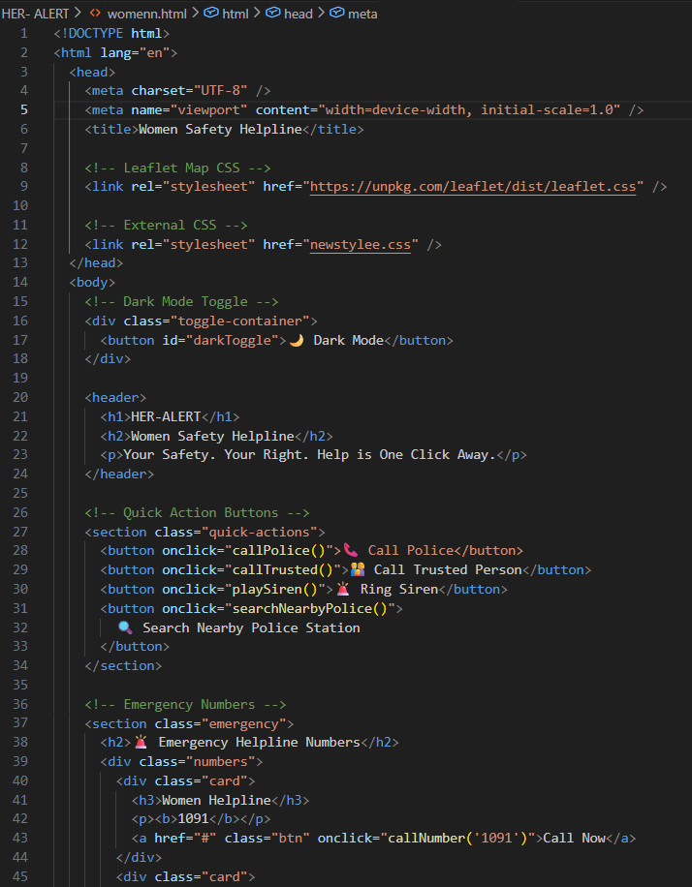

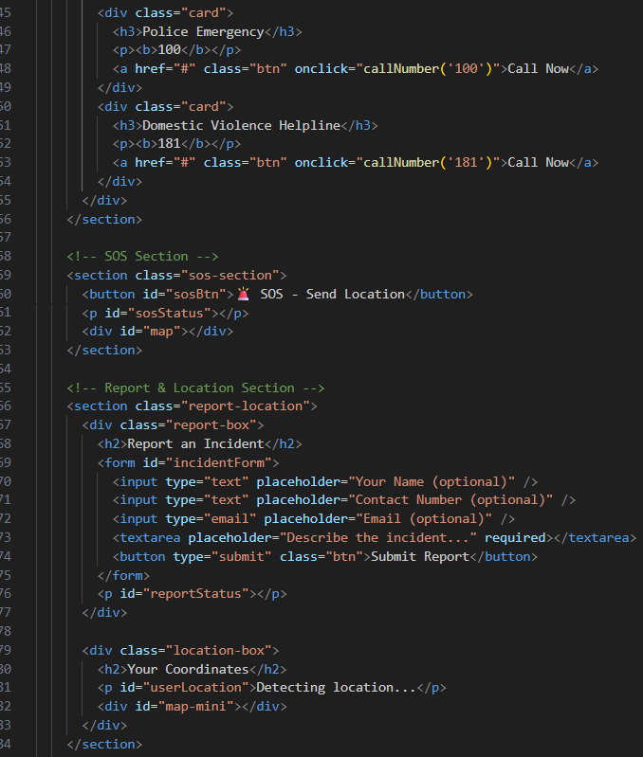

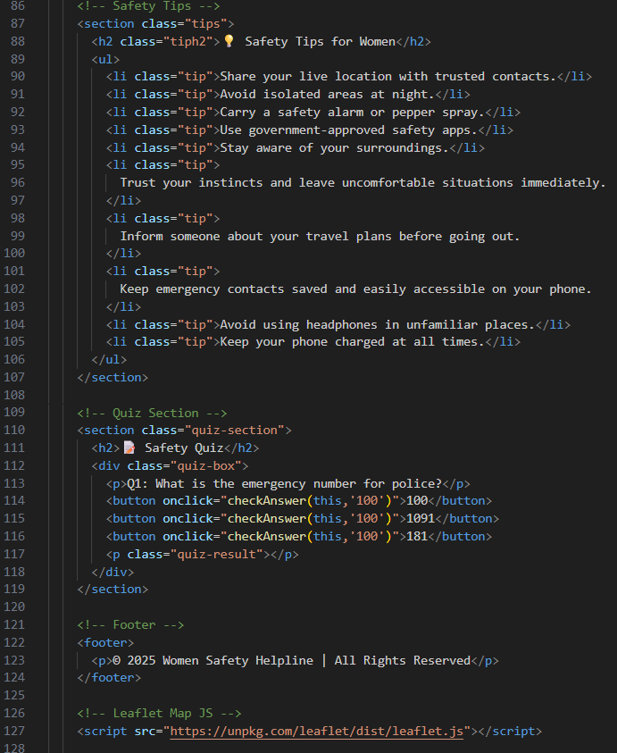

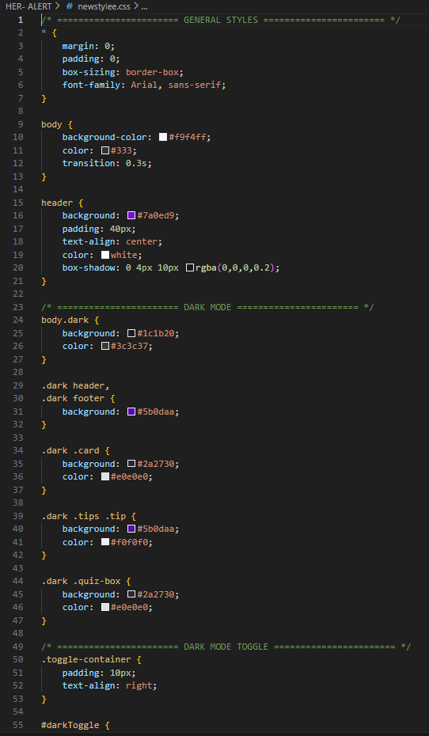
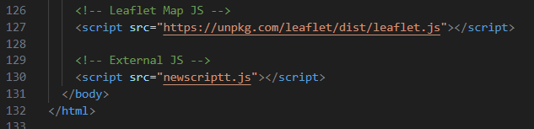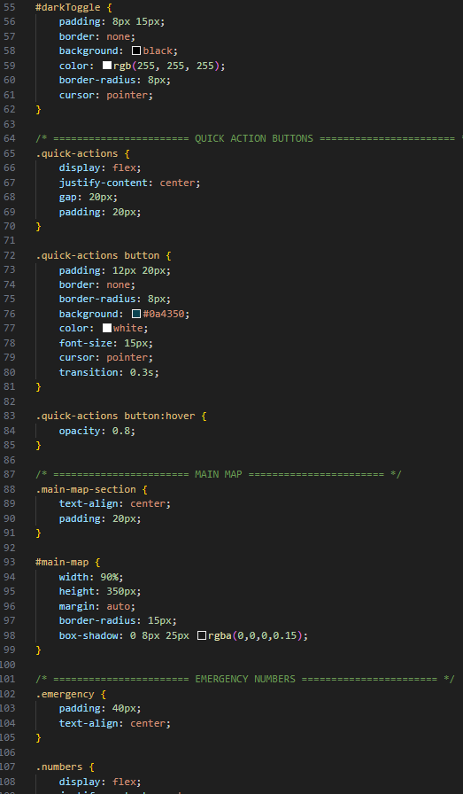

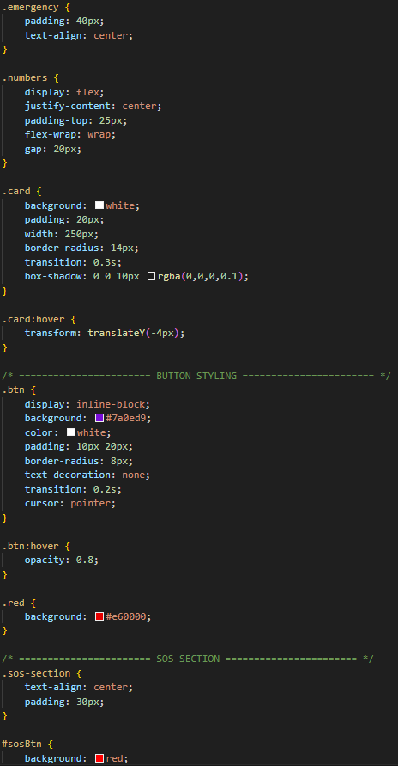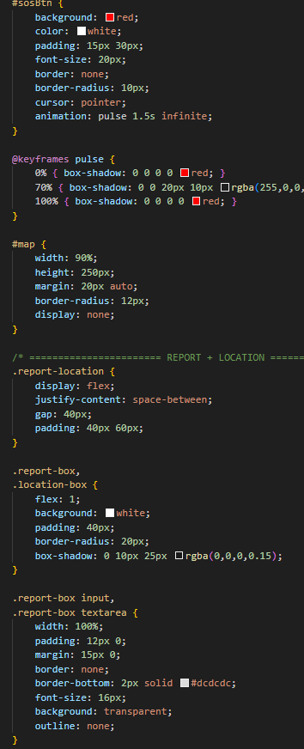

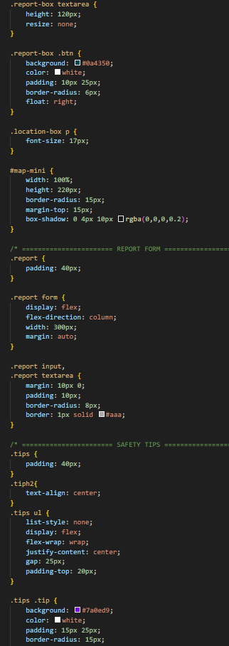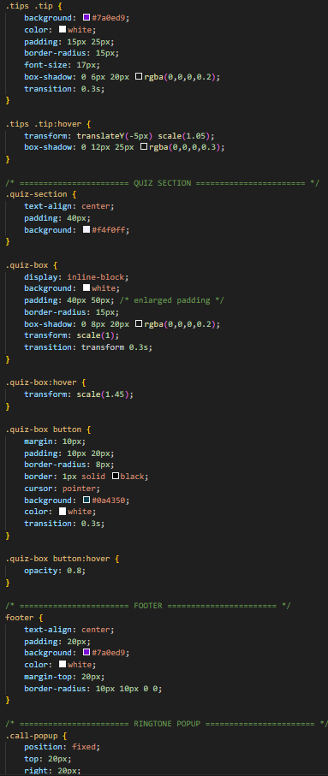

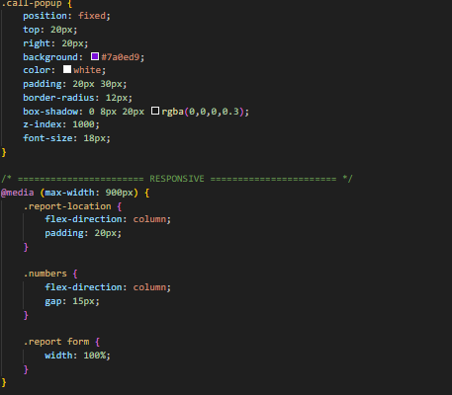

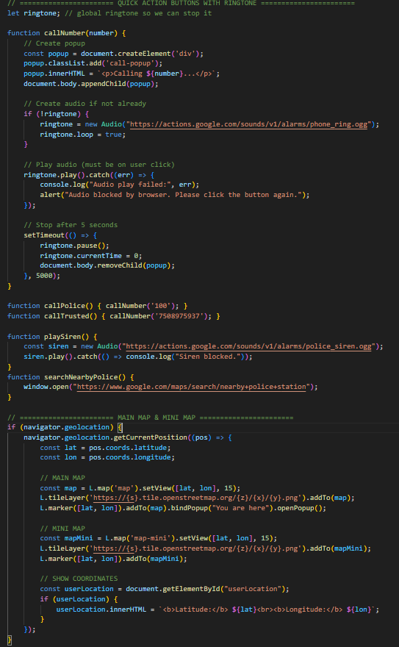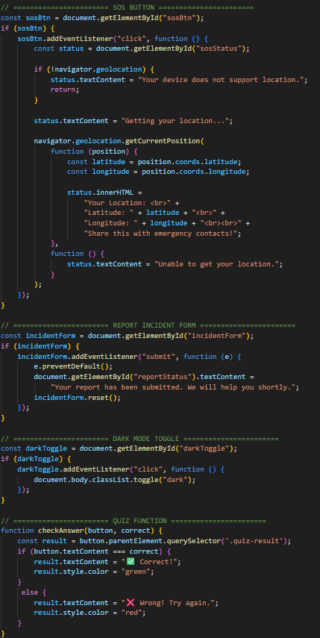

OUTPUTS OF THE PROJECT

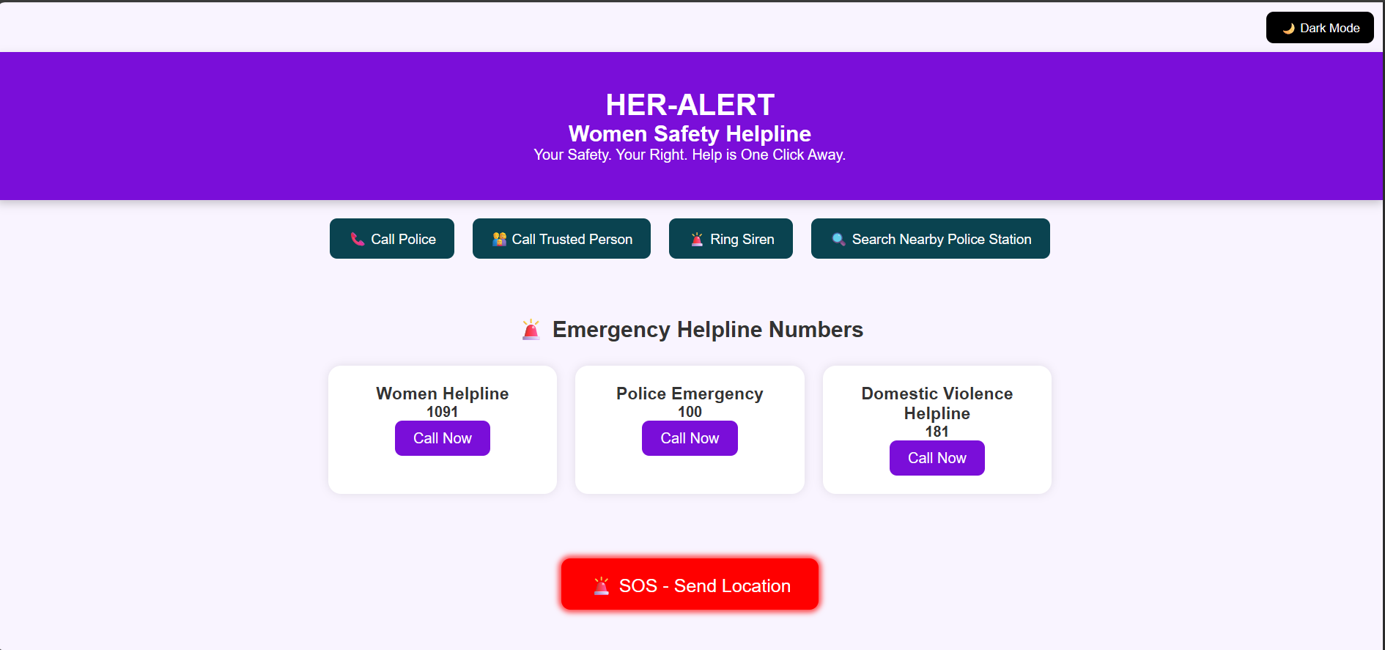

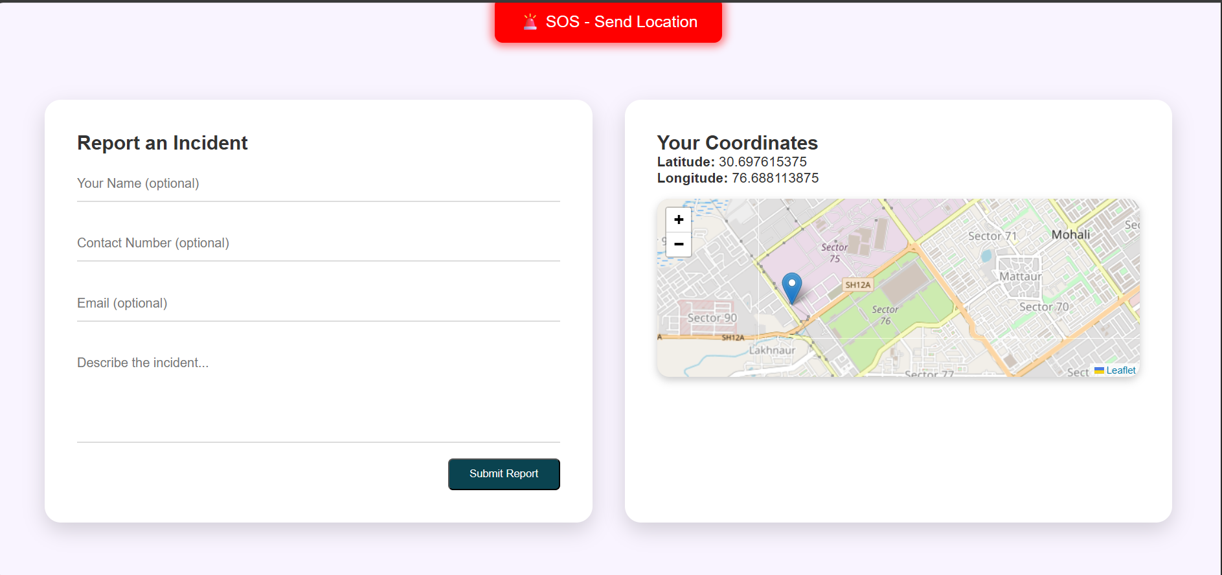

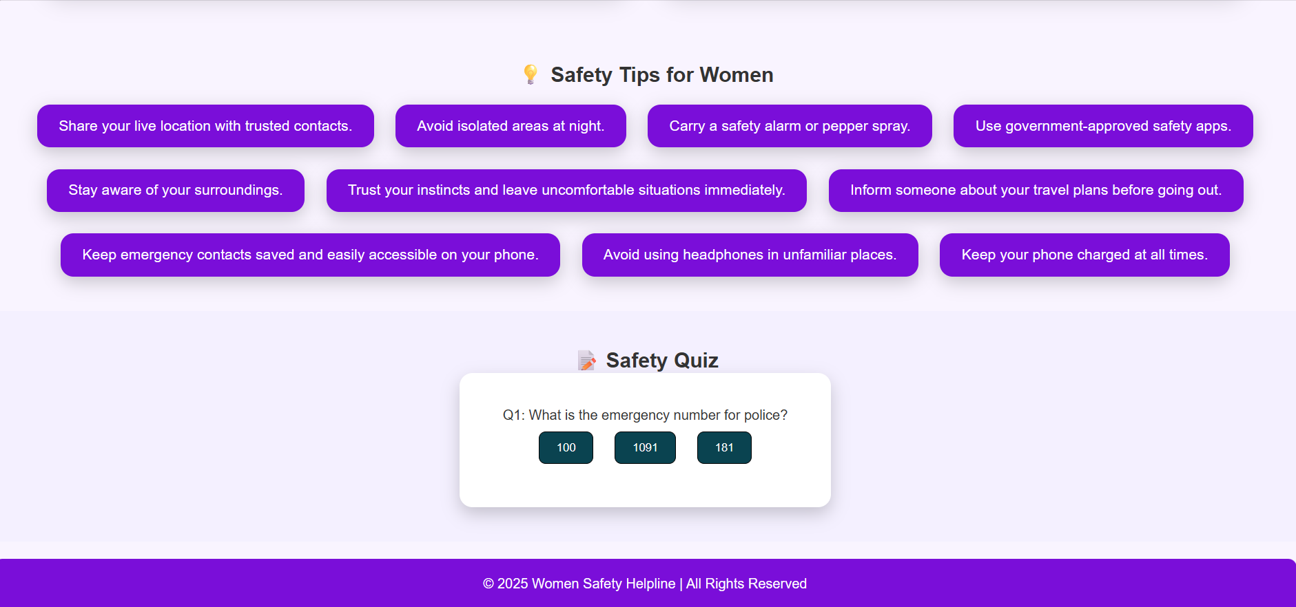

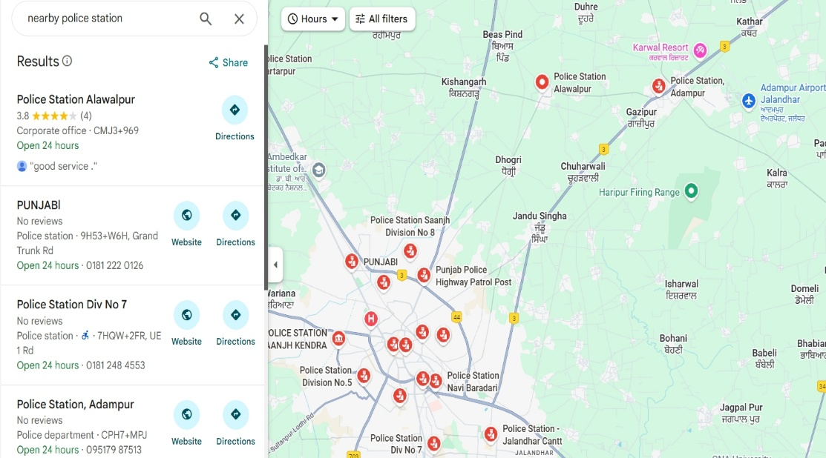

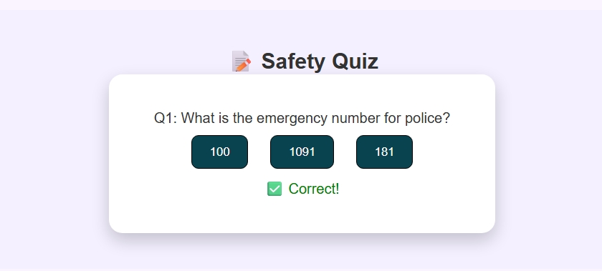

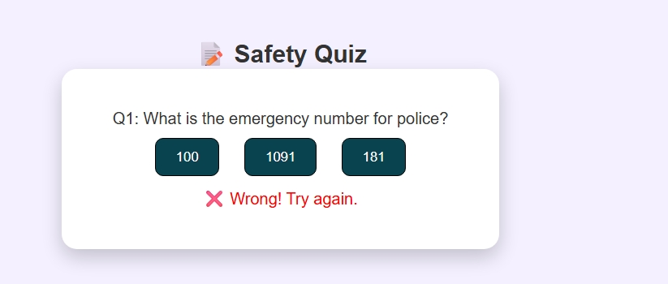

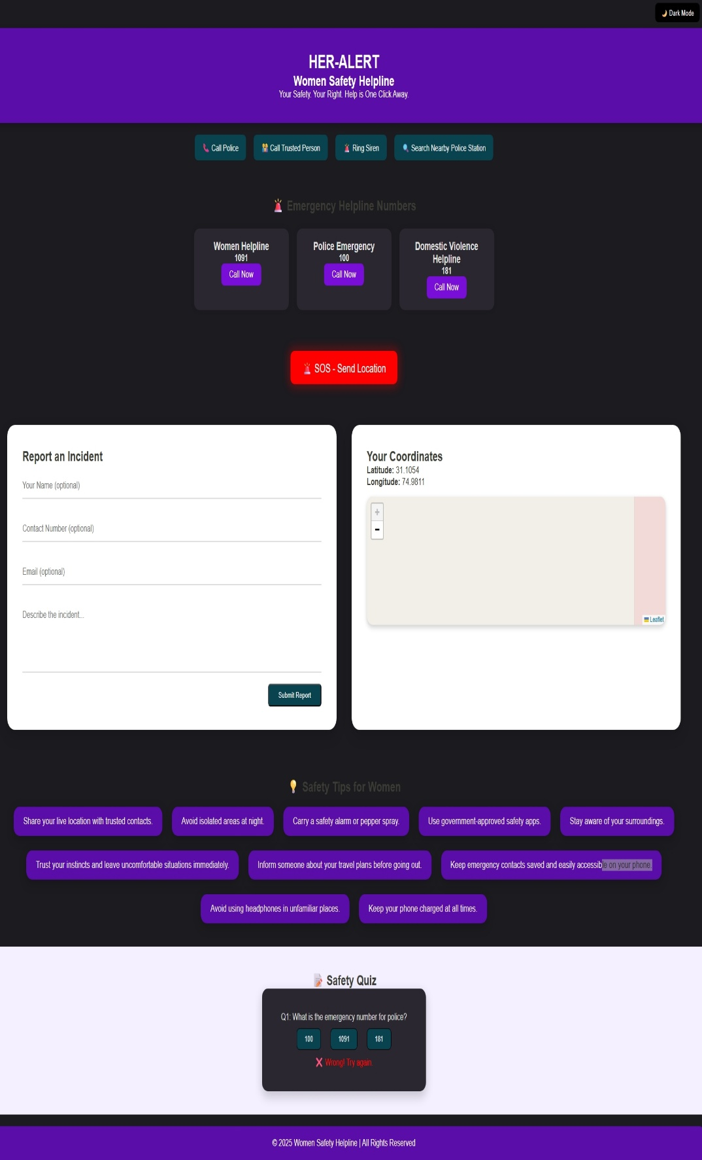

8.FUTURE SCOPE

The Women Safety System can be expanded significantly in the future to enhance its effectiveness, usability, and real-time safety support. As technology continues to evolve, several advanced features can be integrated to improve predictive capabilities, user protection, and overall system intelligence. The following future enhancements can be implemented:

The system can be extended to utilize machine learning algorithms that can analyze crime trends more accurately, predict crime-prone locations, and generate risk-level heatmaps for specific areas. By using historical datasets, the system can automatically identify hidden patterns in criminal activities and assist users in avoiding unsafe routes. Integration of deep learning models can further enhance real-time detection of threats through audio, video, or behaviour analysis.
A major improvement can be made by implementing real-time live tracking with geofencing alerts, where users can share their constant location updates with trusted contacts or nearby police stations. If the user enters a high-risk zone or stops moving unexpectedly, the system can automatically trigger an alert. Incorporating offline mode support can ensure that emergency features function even in areas with low or no internet connectivity by sending SMS-based SOS alerts.
Future versions of the application can integrate biometric-based quick activation, such as double-tap fingerprint, pressure-based triggers, or voice-activated SOS commands that alert authorities instantly without opening the mobile application. This hands-free emergency activation is extremely valuable in high-risk situations.
Finally, the system can evolve into a fully integrated smart wearable ecosystem, where devices like smart bands, pendants, or rings can trigger SOS alerts, send live location, record audio, and notify contacts instantly. These wearables can connect directly with the main platform using Bluetooth or IoT technology

9. CONCLUSION

The successful development of this project using HTML, CSS, and JavaScript demonstrates how powerful and efficient a purely front-end technology stack can be when applied correctly. By structuring the interface with HTML, enhancing visual appeal and responsiveness through CSS, and enabling interactivity with JavaScript, the system achieves a seamless and engaging user experience. Each technology played a crucial role in ensuring that the final application is both functional and easy to navigate.
Throughout the project, emphasis was placed on clean layout design, intuitive user flow, and optimized JavaScript functionality. The implementation highlights the importance of DOM manipulation, event handling, and modular code structure in creating smooth client-side operations without relying on backend frameworks. This also proves that even simple web technologies, when used effectively, can result in a reliable, lightweight, and fast-performing system.
In conclusion, the project fulfils its objectives and demonstrates the practical application of core web development skills. It also provides a strong foundation for future enhancements, such as adding backend connectivity, improving UI components, or integrating advanced JavaScript features. The knowledge gained through this project further strengthens understanding of front-end development and real-world problem solving.

10. REFRENCES

[1] W3Schools, “HTML Tutorial.” [Online]. Available: https://www.w3schools.com/html
[2] MDN Web Docs, “HTML: Hyper Text Markup Language.” [Online]. Available: https://developer.mozilla.org/en-US/docs/Web/HTML
[3] W3C, “Cascading Style Sheets (CSS) Specifications.” [Online]. Available: https://www.w3.org/Style/CSS
[4] MDN Web Docs, “CSS: Cascading Style Sheets.” [Online]. Available: https://developer.mozilla.org/en-US/docs/Web/CSS
[5] MDN Web Docs, “JavaScript Guide.” [Online]. Available: https://developer.mozilla.org/en-US/docs/Web/JavaScript/Guide
[6] ECMA International, “ECMAScript Language Specification.” [Online]. Available: https://www.ecma-international.org
[7] J. Duckett, HTML & CSS: Design and Build Websites. Wiley, 2011.
[8] J. Duckett, JavaScript & jQuery: Interactive Front-End Web Development. Wiley, 2014.
[9] D. Flanagan, JavaScript: The Definitive Guide. O’Reilly Media, 2020.
[10] E. Freeman and E. Robson, Head First HTML and CSS. O’Reilly Media, 2012.
[11] J. Keith and R. Andrews, HTML5 for Web Designers. A Book Apart, 2016.
[12] E. Meyer, CSS: The Definitive Guide. O’Reilly Media, 2011.
[13] D. Crockford, JavaScript: The Good Parts. O’Reilly Media, 2008.
[14] Stack Overflow, “Developer Community Discussions.” [Online]. Available: https://stackoverflow.com
[15] Geeks for Geeks, “Web Development Tutorials.” [Online]. Available: https://www.geeksforgeeks.org

